A2. Data acquisition and cleaning
2.1 Data Sources
The data population data for each borough in New York City (2019 data set) was obtained from the data set found at this web site https://data.beta.nyc/dataset/0ff93d2d-90ba-457c-9f7e-39e47bf2ac5f/resource/7caac650-d082-4aea-9f9b-3681d568e8a5/download/nyc_zip_borough_neighborhoods_pop.csv". This data set has the following information: zip code, post office, borough name, neighborhoods’ names, population value and population density value for each and every neighborhood. The other data set that was used is found at the following address https://cocl.us/new_york_dataset. This data set contains borough names, neighborhood names, latitude and longitude values for each neighborhood .

2.2 Data cleaning
The data downloaded from both sources had no missing values or data types mismatch issues.
2.3 Feature selection
After downloading the data sets and converting them into pandas data frames, the data was analyzed. In the population data set, it was observed that most of the fields were not necessary for the analysis. This data set served the purpose of only identifying the borough in New York City that has the highest population. The image below shows the data frame created from the data set, after downloading data set.
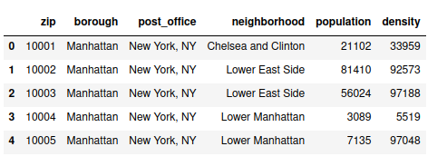

Fig 2.2a
The pandas idmax ( ) method was used to identify the borough with the highest population. This borough was found to be Queens and therefore was the one used for analysis since the restaurant has to be established in an area where there are likely to be more customers.
The next stage was to extract Queens’ data,that is, neighborhood name , latitude and longitude values. The image below shows the data frame with the information.
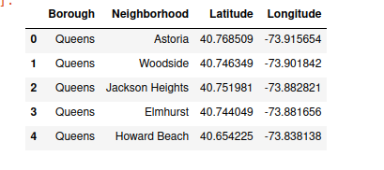

Fig 2.2b
After obtain this data frame, Geopy and Foursquare API were then used to obtain venue ,category information as well as coordinates information, for each neighborhood in Queens. The image below shows the created data frame.
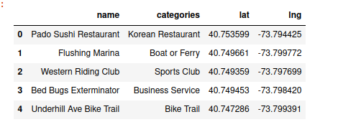

Fig 2.2c
The previous two data frames (Fig 2.2b and 2.2c) were then merged so that neighbors in Queens could be explored. Fig 2.2d shows the resulting data frame
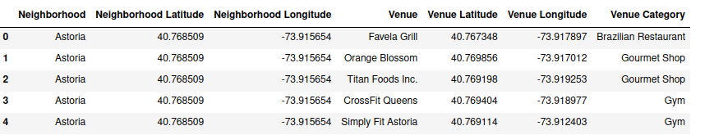
Fig 2.2d
The next step was to use onehot encoding on the above data so that it could be applied to a machine learning algorithm (Kmeans clustering) for further analysis. This resulted in the data frame below.
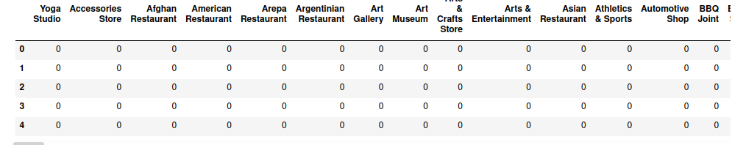
Fig 2.2e

